- Imagine that you are trying to visit www.enterprise.com, but you don't remember the IP address the web-server is running on.
Assume the following records are on the TLD DNS server:
- (www.enterprise.com, dns.enterprise.com, NS)
- (dns.enterprise.com, 146.54.224.15, A)
Assume the following records are on the enterprise.com DNS server:
- (www.enterprise.com, east2.enterprise.com, CNAME)
- (east2.enterprise.com, 142.81.17.206, A)
- (enterprise.com, mail.enterprise.com, MX)
- (mail.enterprise.com, 247.29.162.145, A)
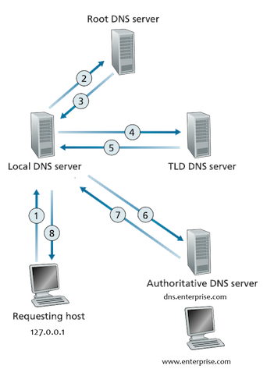
Figure 1

Assume your local DNS server only has the TLD DNS server cached.

  - What transport protocol(s) does DNS use: TCP, UDP, or Both?
  - What well-known port does DNS use? -53
  - In the above example, how many unique type of Resource Records (RR) are there at the authoritative enterprise.com DNS server?-3
  - Can you send multiple DNS questions and get multiple RR answers in one message? Answer with Yes or No
  - To which DNS server does a host send their requests to? Answer with the full name - Local DNS Server
  - Which type of DNS server holds a company's DNS records? Answer with the full name- Authoritative DNS server
  - In the example given in the problem, what is the name of the DNS server for enterprise.com? - dns.enterprise.com
  - When you make the request for www.enterprise.com, your local DNS requests the IP on your behalf. When it contacts the TLD server, how many answers (RR) are returned? – 2
  - In the previous question, there were two responses, one was a NS record and the other an A record. What was the content of the A record? Answer with the format: "name, value" - dns.enterprise.com, 146.54.224.15
  - Assume that the enterprise.com website is actually hosted on east2.enterprise.com, what type of record is needed for this? – CNAME
  - Now imagine we are trying to send an email to admin@enterprise.com, and their mail server has the name mail.enterprise.com. What type of record will contain the name of the enterprise.com domain and the name of its mailserver(s)?- enterprise.com, mail.enterprise.com
  - In that MX record, what are the contents? Answer with the format: "name, value" - enterprise.com, mail.enterprise.com
  - Does your local DNS server take advantage of caching like web requests? Answer with Yes or No –

- Suppose Alice, with a Web-based e-mail account (such as Hotmail or Gmail), sends a message to Bob, who accesses his mail from his mail server using IMAP. Discuss how the message gets from Alice’s host to Bob’s host. Be sure to list the series of application-layer protocols that are used to move the message between the two hosts.
- Is it possible for an organization’s Web server and mail server to have exactly the same alias for a hostname (for example, foo.com)? What would be the type for the RR that contains the hostname of the mail server?
- In BitTorrent, suppose Alice provides chunks to Bob throughout a 30-second interval. Will Bob necessarily return the favor and provide chunks to Alice in this same interval? Why or why not?
- Consider a new peer Alice that joins BitTorrent without possessing any chunks. Without any chunks, she cannot become a top-four uploader for any of the other peers, since she has nothing to upload. How then will Alice get her first chunk?
- Use nslookup on your local host to send DNS queries to three DNS servers: your local DNS server and the two other DNS servers. Try querying for Type A, NS, and MX records. Summarize your findings.
- Explain about Dynamic Adaptive Streaming over HTTP.

